**Be flexible with your routine.**   
**Mix up your strength exercises.**

Exercise Library: <http://www.sparkpeople.com/resource/exercise_demos.asp?exercise_type=core>

**“Work in” between sets.**

**Go for the unconventional.**

**Use the group fitness room.**

**Take it outside.**

**Consider a 24-hour option.**

**App tracks UCLA gyms’ traffic**

APP: <http://www.mygymflow.com/>

An iPhone application called GymFlow, that tracks the traffic in recreation centers to fit the UCLA community.

lists all hours for each room inside the John Wooden Center as well as the schedule of fitness classes offered.   
  
The app calculates the overall traffic of the gym through how many BruinCards have been swiped.

The app describes traffic through three different levels: slow, moderate and busy.

Right now, the app also covers Group Exercise classes, which are specific to those who purchase fitness passes.

**数学统计做预测**

<https://fitness.mindbodyonline.com/fitness-business-management-software/welcome-48Z2-32561L.html?campaignID=70160000000PmPI&utm_adgroup=gym_cloud&utm_term=gym+cloud&utm_campaign=Fitness&utm_source=Google&utm_medium=PPC>

https://d76623b93dc74f3d672d-fcc7d3067dbf904677b3b80c94a8f9f9.ssl.cf1.rackcdn.com/global/imagelib/logos/mb_logo_alt_lg-b00a605e0ab9188ead7391ed061c3a9c6647c1b6.png

### The whole schedule, in one place.

Create a master schedule once with every fitness class and every instructor. Then access it whenever you need to, from your front desk, tablet or phone.

### Better recordkeeping for every client.

Store everything that matters in one simple client profile: visit history, past payments, training preferences, contracts and waivers, birthdays and more.

### Hassle-free payments.

Collect monthly membership dues and renew class passes automatically, process credit cards at competitive rates and sell your products and services quickly.

<http://www.gymcloud.com/>

# GymCloud is a cloud-based fitness platform designed to enhance the interaction between fitness professionals and their clientele. GymCloud allows users to easily create exercises, assign workouts, develop programs and track exercise performance. Unlike traditional training methods, GymCloud offers the unique ability to create your own custom digital platform to share information, such as instructional videos, training tips, or nutritional advice.

This online personal training software and app has all of the required features for a personal trainer to schedule an exercise routine and also give advice and feedback. GymCloud fitness programming software allows trainers to effectively and efficiently communicate with clients, build and assign custom workout programs, and track their clients’ progress from anywhere, anytime! Workout programming in the gym has never been easier as remote personal training software allows clients to achieve their fitness goals.

# From Wellness System to mywellness® cloud



Wellness System, the first solution in the world providing training system management, was developed by Technogym way back in 1996: a ground-breaking step in fitness data tracking and management. Members used a Technogym WS key to track their activity within fitness facilities using the server-based Wellness System.

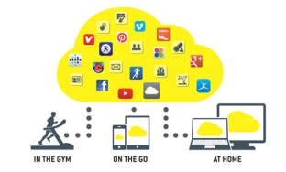

Technogym is taking data tracking, and centralising data for easy access, to the next level:[mywellness® cloud](http://www.technogym.com/us/solutions/fitness-centers/mywellness-cloud/16172) is Technogym's cloud-based LIFESTYLE CRM that enriches people's training experience, and gives operators the tools to improve their business and stay in touch with their customers – even when they're not in the gym.

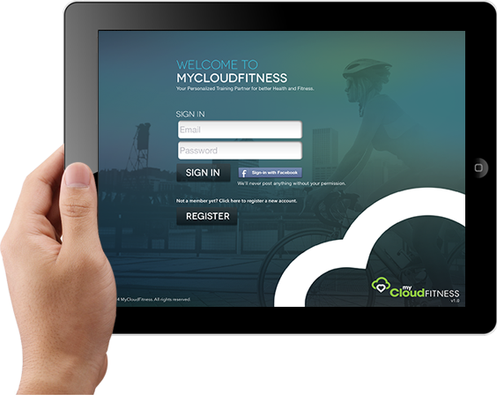

<http://mycloudfitness.com/>

myCloudFitness: the personalized training partner

<http://www.cloudtrainingsystems.com/>

**Cloud Training offers the freedom to write, manage, and monitor any size team or organization anytime, anywhere.**

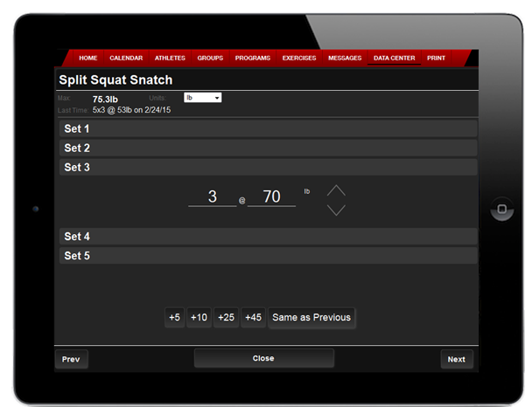

**Track Development**

Cloud Training allows an athlete or coach to enter results from a workout to track how far they have come in their training. Maxes are automatically updated. Graphs the results to visualize their progress. Another benefit is injury prevention. Unexpected drops in performance are tracked to spot over-training so future workouts can be adjusted accordingly.

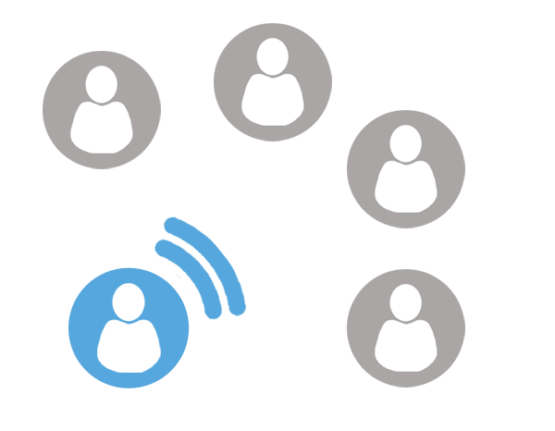

**Team Messaging**

Cloud Training allows for individual and group messaging with SMS (text), E-mail, and phone calls. Communicate with your athletes, parents, and your staff instantly with a few clicks of a button. Know with certainty that your team is aware of practice times, cancelations, meetings and weather alerts. Easily keep everyone in the loop.

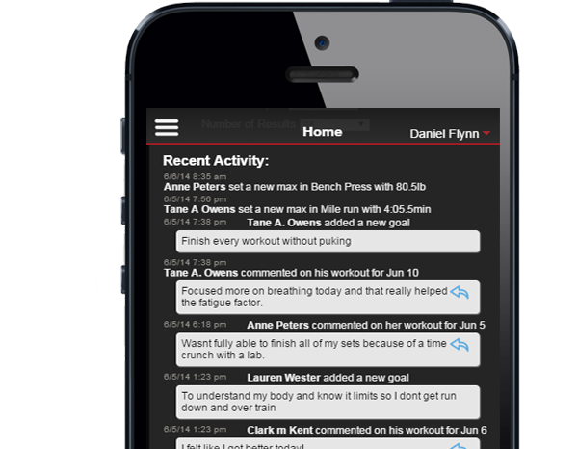

**Administrative Oversight**

Stay in the loop with what is going on inside the team or Organization with Cloud Training’s Activity Feed. With a glance see what your athletes and coaches are doing. Know about training schedule changes, group changes, athlete comments, new maxes …etc. Practically all aspects of the inner workings of your team are tracked so nothing slips through the cracks.



**Exercise Database**

Our exercise database consists of 700+ searchable and categorized exercises. Easily determine proper technique by watching a video, viewing photos, or a step-by-step description of how the exercise is supposed to be performed. Giving you piece of mind that your athletes have the resources needed to perform the exercise safely and correctly.



**Customizable Workouts**

With Cloud Training you are limited to a set stock of workouts like other training software. Cloud Training takes pride in its flexibility to handle almost any sport, workout or drills that you can come up with. If you can think of it, it can be implemented into your workout with Cloud Training.

<http://readwrite.com/2012/04/18/fitness_apps_for_ios_and_android>

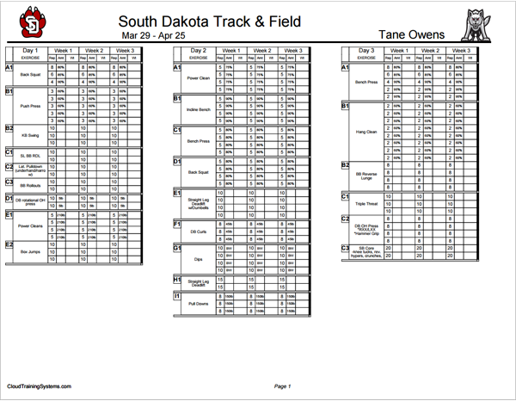

**Individualized Workout Sheets**

Cloud Training gives the ability to print individual workout sheets in a variety of different formats. Each can contain the organization’s logos and athletes names. Along with no longer just giving percentages, the sheets reference the clients/athletes max so they don’t have to use any look-up tables or conversion charts to know what 85% of their 192lbs max in bench.